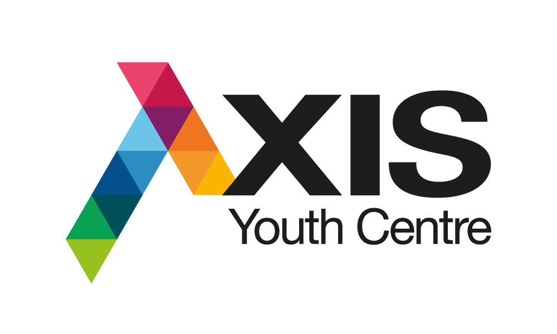
AXIS Youth Centre
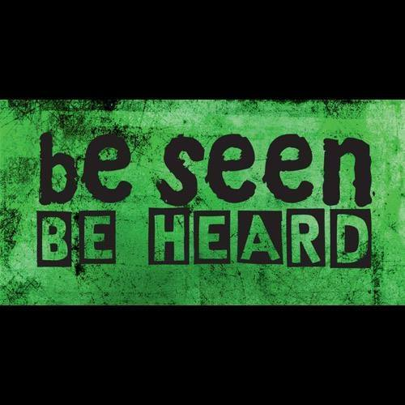

Queanbeyan-Palerang Regional Council
Ph: 0466 409 896

Consent for Collaborative Youth Services
School Holiday Program - Spring 2020

I (parent/guardian) hereby give permission for to participate in the Queanbeyan-Palerang Regional Council (AXIS Youth Centre) and Goulburn Mulwaree Council School Holiday Program in September-October 2020 under the guidance of Council’s Youth Services staff.

I give permission for my child/young person to participate in the following activities:
ONLINE:
All online activities including video games, trivia and arts and cooking YES NO
FACE-TO-FACE:
Park catch up session Friday 2nd October* YES NO
Park catch up session Friday 9th October* YES NO
*Please note that face-to-face activities are restricted to 20 participants. We will confirm your child/young person’s participation in these events.
As most programs will be delivered on line using Zoom please provide us with an email and mobile phone number so that we can send the link, password and instructions on how to join the group:
Email:
Mobile:
We will be organising and providing free equipment packs for each of the online activities. These packs will be delivered to your chosen address via contactless delivery to minimise person to person contact.
Address:

Photo and Media Permission:
I give permission for photographs and videos of my child/young person to be taken for advertisement, promotion and social media purposes.
□ Yes □ No

Medical Information for Face-To-Face Activities:

My child/young person has the following medical conditions (list conditions such as diabetes, epilepsy, asthma or allergies):
....................................................................................................................................................................................................................................................................................................................................................................................................................................................................................
Note: If your child has an Emergency Action Plan, a copy MUST be provided.
My child/young person is currently taking the following medications (list all medications): ....................................................................................................................................................................................................................................................................................................................................................................................................................................................................................I give permission for my child/young person to receive medical treatment in case of emergency
Yes No
I hold ambulance cover? Yes No
Details of ambulance cover: _____________________________________________________
Covid-19 Safety Restrictions:
I understand that participation in face-to-face activities are subject to COVID-19 safety restrictions. This includes temperature checks, registering of details, hand sanitizing, social distancing and restricted amount of participants. I understand that my child/young person’s participation in the programs are subject to them following COVID-19 safety restrictions and related instructions given by AXIS Youth Centre Staff.
□ Yes □ No

Permission Slip:
By signing this document, I indemnify AXIS Youth Centre Staff and other Council Youth Services Officers from all liability, claims or actions directly or indirectly arising from these activities. Furthermore, I understand that should my child/young person leave the activity, or act against the direction of Council staff, QPRC and AXIS Youth Centre will not be liable for any accidents or injuries incurred.

Each activity will have an Instructor and Youth Worker available to support and help participants throughout the activities. The same rules apply to the online activities as they would if they were participating in a normal school holiday program. If there is any inappropriate behaviour or language towards staff or other participants, your child/young person will be disconnected from the activity.

As these programs will be delivered online and not in person, it is the responsibility of parents/ carers to monitor and care for your child/young person throughout the designated sessions. Please note Council Youth Services staff take no responsibility for inappropriate computer/internet usage ie. access to websites deemed unsuitable for those under 18. Council staff reserves the right to not allow your child/young person to attend the virtual sessions and activities if they do not follow directions and rules.

Signature of Parent/Guardian Date

Signature of Child/Young Person Date

Please return completed consent forms via email to axisyc@qprc.nsw.gov.au by Wednesday 23 September 2020

Note:
Council collects personal information only for a lawful purpose that is directly related to Council’s functions and activities. For further information please refer to Council’s Privacy Management Policy at www.qprc.nsw.gov.au

If you have any questions or enquiries please contact:
Rebecca Legge – Youth Development Team Leader on 0466 409 896 or email rebecca.legge@qprc.nsw.gov.au

